Case 6-Afr- Mali-Tellem-Nommo-Sandstone Figurine-Mopti-Bandiagara Escarpment-ca 1250-1450 CE

 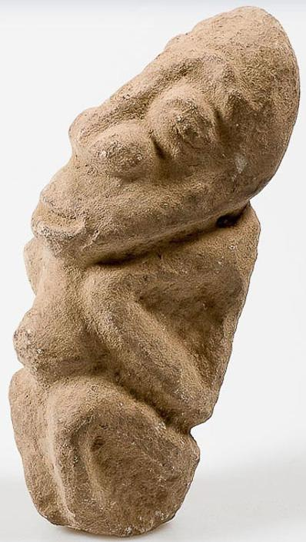

Fig. 1. Mali-Tellem-Nommo-Sandstone Figurine-Mopti-Bandiagara Escarpment-ca 1250-1450 CE

**Case no.: 6**

**Accession Number:**

**Formal Label:** Mali-Tellem-Nommo-Sandstone Figurine-Mopti-Bandiagara Escarpment-ca 1250-1450 CE **Display Description:**

This Tellem figurine was carved during a period of drought corresponding to the first half of the Little Ice Age (ca. 1250-1450 CE). The key to this ancient sandstone figure is the bent and angular posturing of the arms that was adopted by the Dogon in their development of the Nommo configuration of the stool “legs” on which Nyerum sits. This angular configuration, similar to the Egyptian sign for water which represents Rain falling from Sky to Earth, is the iconic feature of the Tellem version of Nommo, the cosmic source of water. During this period of drought, Nommo was invoked for rain. Nommo is the male cosmological framework upon which Nyerum’s social control of water is predicated. This figure of Nommo would have been placed in a shrine near a water source to whom prayers would have been made to insure the well-being of the community.

The Tellem were pygmies or termed "small red people" by the Dogon. They built dwellings along the base of the Bandiagara Escarpment usually under an overhang. They placed their dead high on the cliff-face away from the frequent flash floods during the period 800-1250 CE. Many of these burial structures are still visible along the cliff face. Some Tellem buildings, most notably the granaries, are still in use by the Dogon. However, the Dogon founded their villages along the base and along the top of the Escarpment, where surface water was available and farming iwas possible.

The Tellem people disappeared for unknown reasons, in the 14th c coincident with the arrival of the Dogon and perhaps the Black Death. Dozens of Tellem villages were left as they were, abandoned along the cliff face, such as Kani Bonzon near to where the Dogon arrived in the 14th century. Afterwards the Dogon migrated over the plateau and the plains of Seno-Gondo.

**LC Classification:** DT551.42

**Date or Time Horizon:** ca 1450

**Geographical Area:** site of Djenné-Djeno, Mali, on the flood plain of the Bani River,3 km (1.9 mi) s of modern town.

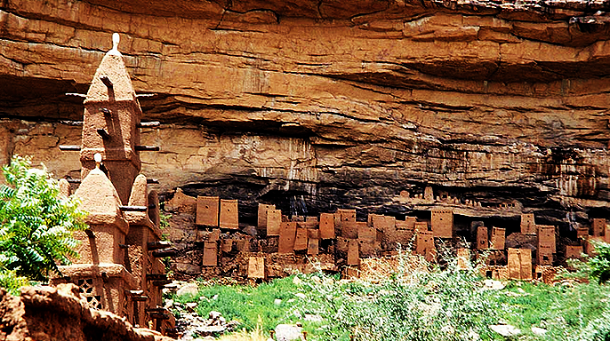

Fig. 2. Abandoned dwellings of the Tellem people in the background along the Bandiagara Escarpment, Mali, with a mud mosque of the modern-day Dogon village at the left, foreground, after <http://www.apsaidal.com/wp-content/uploads/2017/03/Tellem_Dwelling_Bandiagara_Escarpment_Mali.jpg>

**Map:**

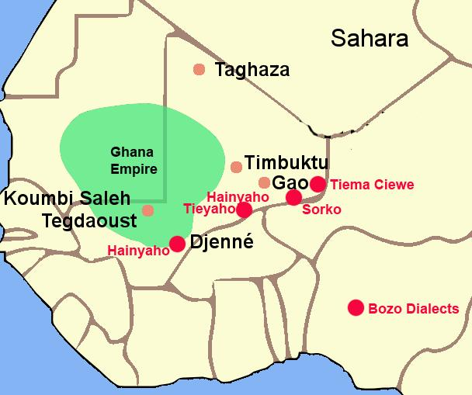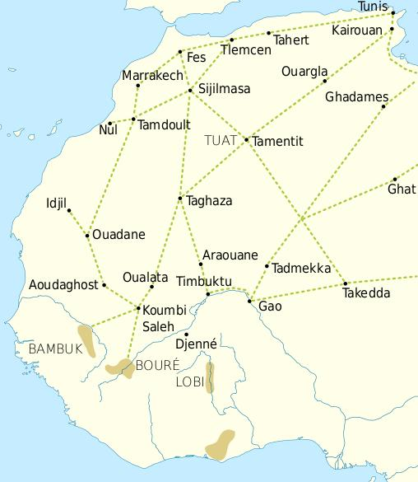

Fig. 3. The Ghana Empire 1000-1400 CE showing the ethnolinguistic groups along the Niger River. After <https://i.pinimg.com/564x/c6/a7/9b/c6a79b7443105f363ff965ebf420b7fd.jpg>

Fig. 4. Trade routes of the Western Sahara c. 1000-1500 along which the Black Death may have penetrated West Africa. Goldfields are indicated by light brown shading. After https://i.pinimg.com/564x/69/15/ce/6915ce6f4fd34025787fe59bd44f9eae.jpg

This trade resulted in an increasing surplus that helped expand urban centers such as Gao, Timbuktu and Djenné.

**GPS coordinates:** Djenné-Djeno, Mali: [13°53′26″N 4°32′25″W](https://tools.wmflabs.org/geohack/geohack.php?pagename=Djenn%C3%A9-Djenno&params=13_53_26_N_4_32_25_W_region:ML_type:landmark_source:dewiki)

**Geographical Area:** Bandiagara Escarpment

|  |  |
| --- | --- |
|  |  |

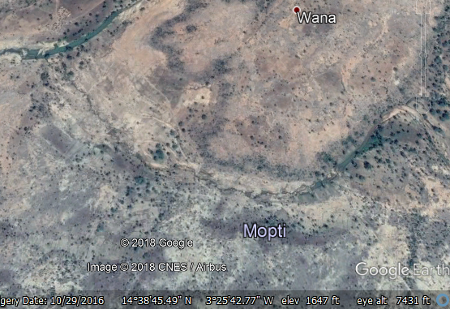

**Fig. 5.** [Mopti Region](https://en.wikipedia.org/wiki/Mopti_Region), Mali

**GPS coordinates:** [14°29′54″N 3°11′9″W](https://tools.wmflabs.org/geohack/geohack.php?pagename=Mopti_Region&params=14_29_54_N_3_11_9_W_type:adm1st_region:ML_source:nlwiki)

**Cultural Affiliation:** Tellem

**Medium:** sandstone

**Dimensions:**

**Weight:**

**Condition: original.**

**Provenance:** Bandiagara village 1998.

**Discussion:**

The Tellem version of Nommo was the source of water, but he was also an apotropaic spirit that protected the people from disease. Although the Black death reached North Africa in 1348, records do not show that it was carried by traders to the Bandiagara Escarpment communities. However, Dogon migrations were active at the time and they would have brought the disease with their caravans. The disappearance of the Tellem at this time is probably more than coincidental, since they abandoned their vilages with all of their stocks of game and gran in place. Therefore, the disappearance of the Tellem may be related to the Black Death.

Indeed, the Black Death bacterium *Yersinia pestis*, a zoonotic bacterium in small mammals and their fleas was carried along the marine Muslim routes of Hajj from Central Asia to Guandong, China, to Mecca in 1348 and within the year it spread across North Africa to Marrakesh. Since the Dogon were actively arriving in the Bandiagara Escarpment at this time, they may have carried Black Death in their caravans. It would have given added significance to the Tellem version of Nommo as an apotropaic agent of protection against disease. The Catalan Map of 1375 indicates how these Dogon traders would have appeared to the Tellem 40 years later.

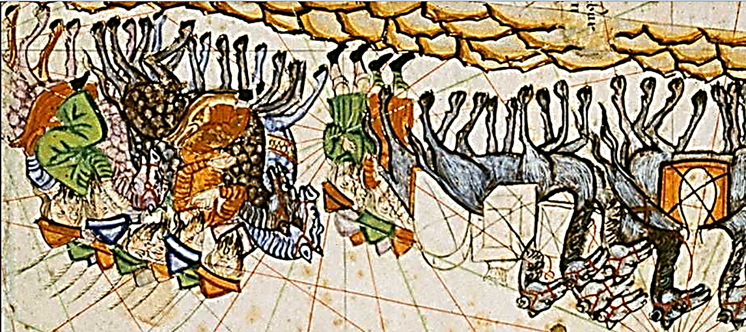

Fig. 5. Catalan map detail showing Muslim traders and their slaves crossing the Sahara Desert, ca 1375. After <http://expositions.bnf.fr/marine/albums/catalan/index.htm>



Fig. 6. Detail showing a horseless slave holding an object around his neck, perhaps a charm as an apotropaic protection against disease.

While Europeans preferred to flee from the plague, thus spreading it, Muslims disagreed, and there was debate based on the Quaran and the Hadith on whether or not flight was the best option. It depended on the condition; for example, where was the plague, at a low elevation, or in marshes, or stagnant waters, and what were the exposures from the south, cool areas, dry areas, and mountainous areas. If this scholarly analysis weren’t feasible then conditions where areas were considered safe or free from the plague were to be copied. People were advised by the mullahs to stay inside, and cover their bodies from sunlight, and especially to stay cool. Islamic scholars detested flight based on the profound religious belief that the plague was seen as God's doing: Allah's will was inevitable and so fleeing was both useless and unnecessary. Muslims also used charms to guard against the plague, and they would have appreciated this sandstone sculpture as the Tellem effort to resist the disease.

Tellem people who were ensconced along the Bandiagara Escarpment would have been especially vulnerable when the Dogon caravans arrived with their camels and the bacterium. Without a way to combat the disease by either flight or medicine the Tellem may simply have succumbed to the horrors of the Bubonic plague. If this sandstone figurine were sculpted about 1348 it may have been an attempt by the Tellem to invoke their version of Nommo to protect them from the pandemic, of course, without success.

**References:**

Byrne, Joseph Patrick. 2004. *The Black Death*. New York: Greenwood Publishing Group.

Ezra, Kate. 1988. *Art of the Dogon: Selections from the Lester Wunderman Collection*. New York: The Metropolitan Museum of Art, no.44.

Imperato, Pascal James. 1978. "The art of Mali's Mountain People." In *Dogon Cliff Dwellers*. New York: L. Kahan Gallery, New York.

Laude, Jean. *African Art of the Dogon: The Myths of the Cliff Dwellers*. New York: Brooklyn Museum, 1973, no. 73.

Meauze, Pierre. 1968. *African Art: Sculpture*. English translation ed. Cleveland: World Publishing Company.  
Musée Dapper. 1994. *Dogon*. Paris: Editions Dapper.